ASSIGNMENT 8 (c) — Section 2 AAA
(Authentication, Authorization, Accounting)
Shreya Panchal
Topic: AAA Functions in Popular Apps, Wi-Fi Access Control Diagram, Deployment Case Studies

Theory Overview

1. The Core Framework of AAA
AAA represents three distinct security functions designed to manage network and application entry points.
Authentication: Validates the genuine identity of a user, platform, or entity before granting any system access.
Authorization: Defines the exact permissions, read/write privileges, and features the validated user is permitted to use.
Accounting: Reviews, tracks, and documents the consumption of resources, active session periods, and key user operations.

2. Centralized vs. Distributed AAA in Enterprise
Centralized Deployment: Queries a single cluster or master server pool (e.g., RADIUS) to process all incoming user requests. It enforces consistent rules across multiple physical locations.
Distributed Deployment: Stores credential databases and rules individually on separate routers, local systems, or independent branch environments.

Tasks & Answers

Task 1: AAA Real-World Application Examples Table
Question: Create a table comparing Authentication, Authorization, and Accounting (AAA) by listing at least two real-world examples of each function from popular apps like Instagram, Zomato, or Paytm.
Answer:
AAA Function | Core Definition | Example 1 (Paytm) | Example 2 (Zomato / Instagram)
Authentication | Verifying the actual identity of the user trying to open the app. | Scanning your fingerprint/FaceID or entering a 4-digit security PIN to log into your wallet. | Entering a username/password or typing a 6-digit OTP code sent via SMS to access an Instagram account.
Authorization | Assigning specific feature privileges based on the user profile. | Allowing a user to spend money up to their daily bank limit, but blocking access to another user's wallet profile. | Allowing a Zomato delivery driver to update order delivery markers, while preventing customers from modifying restaurant menus.
Accounting | Logging, auditing, and tracking user activities and transactions. | Generating a digital passbook transaction history entry containing the exact timestamp, amount, and reference ID of a money transfer. | Tracking a customer's live GPS location stream and logging their food order checkout patterns for business analytics.

Task 2: Campus Wi-Fi AAA Network Diagram
Question: Draw a simple network diagram showing how AAA is used to secure access to a Wi-Fi network in a college campus, labeling where authentication, authorization, and accounting take place. Include devices like user laptops, access points, AAA server, and the internet gateway.
Answer:
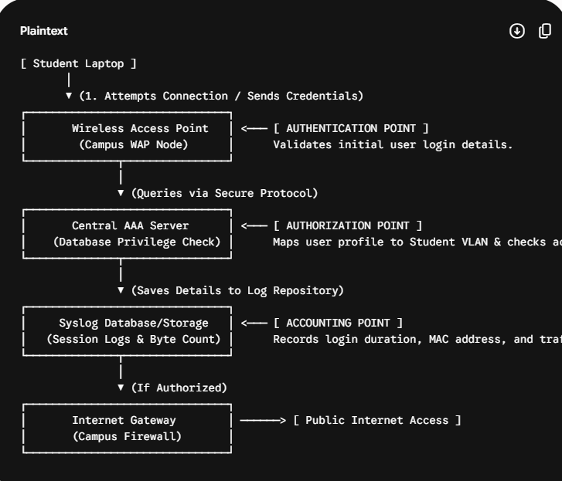

Task 3: Flipkart Warehouse Case Study — Centralized vs. Distributed AAA
Question: Explain the difference between centralized and distributed AAA deployment models by describing how each would work in a scenario where multiple Flipkart warehouses need secure network access.
Answer:
Centralized AAA Approach: If Flipkart deploys a centralized architecture, all regional warehouses (e.g., in Delhi, Mumbai, and Bangalore) connect back to a master AAA server database hosted at corporate headquarters. When a warehouse worker scans a product barcode with a network scanner, the local router requests verification from the core server.
Result: Any modification to worker access permissions updates across all warehouses instantly. However, if the main link to headquarters goes offline, workers cannot log into their scanning devices.
Distributed AAA Approach: If Flipkart deploys a distributed architecture, each warehouse operates its own isolated local identity server or local configuration tables.
Result: If the corporate network line fails, the local warehouse operations continue running smoothly. However, the IT team must manually modify worker access permissions across every individual warehouse server one by one, increasing configuration drift and security risks.

Task 4: BookMyShow Platform Infrastructure Analysis
Question: Pick any one AAA deployment model and list three advantages and two disadvantages of using it for a large-scale app like BookMyShow.
Answer:
Selected Model: Centralized AAA Deployment Model
Advantages:
Unified Fraud Prevention: If a suspicious client logs in or targets the billing APIs, security admins can block the account instantly across all application services from one console.
Simplified Compliance Auditing: All ticket payment histories and user actions compile into a single central logging repository, simplifying security audits.
Consistent Customer Profiling: A user profile updates seamlessly regardless of whether the user accesses BookMyShow via the mobile app, desktop web browser, or a movie theater kiosk.
Disadvantages:
Single Point of Failure Vulnerability: During a high-demand ticket release (such as a major concert tour), if the central AAA database experiences a traffic bottleneck or crash, the entire application drops offline globally.
Increased API Session Latency: User validation queries must travel across external cloud links to the central data store, which can add lag during peak reservation windows.

Task 5: Food Delivery App AAA Policy
Question: Use ChatGPT or another AI tool to generate a sample AAA policy for a Zomato-like app, specifying what actions are authenticated, which roles are authorized for each action, and what accounting logs should be kept. Paste the generated policy and highlight one thing you would change to make it more secure.
Answer:
Generated Application Policy:
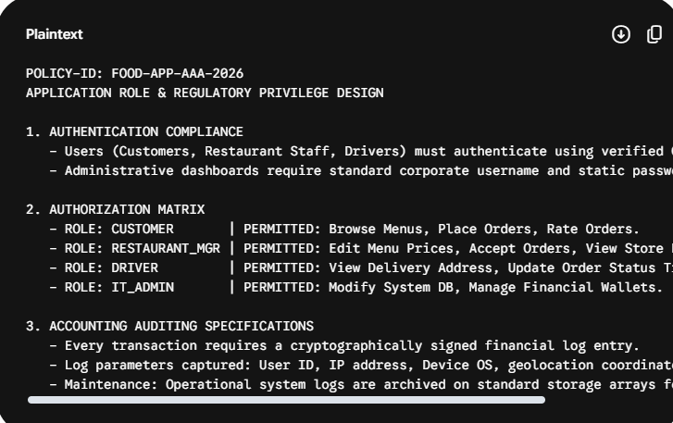
Security Modification Improvement:
Critical Security Modification: In Section 1 (Authentication), the policy allows administrative dashboards to use a "standard corporate username and static password." To make this secure, I would modify the policy to mandate Multi-Factor Authentication (MFA) along with Single Sign-On (SSO) for all administrator accounts. Static passwords are highly vulnerable to phishing attacks, and compromising an administrator profile could expose backend user data and restaurant financial systems.

